CS 499 Module One Assignment Template

Complete this template by replacing the bracketed text with the relevant information.

- Self-Introduction: Address all of the following questions to introduce yourself.

  - How long have you been in the Computer Science program?
I have been in the Computer Science program for 3 years. I have gotten my associates in IT before this and some of the credits transferred.

  - What have you learned while in the program? List three of the most important concepts or skills you have learned.
  - I have learned different programming languages including Java, JavaScript, Python, and C#.
  - Database design and implementation using SQL and NoSQL.
  - Algorithms and data structures

  - Discuss the specific skills you aim to demonstrate through your enhancements to reach each of the course outcomes.
I hope to demonstrate I can improve software structure, create algorithms, and increase security in databases.

  - How do the specific skills you will demonstrate align with your career plans related to your degree?
These skills are needed as a software engineer at Walmart. Improving how I design, software, write algorithms, and work with databases are needed for the career I am hoping to achieve after graduation.

  - How does this contribute to the specialization you are targeting for your career?
These improvements support my specialization of full-stack development. They show that I can work with the entire application stack, from UI to logic to data storage. This will increase my proficiency as a full-stack developer.

- ePortfolio Set Up:

  - Submit a screen capture of your ePortfolio GitHub Pages home page that clearly shows your URL.
    - You already have a repository in GitHub where you uploaded projects in previous courses. Your ePortfolio will reside in GitHub but can link to work at other sites, such as Bitbucket.

  - Use the GitHub Pages link in the Resource section for directions on:
    - How to create your GitHub website and publish code to GitHub Pages
    - Issues, such as adding links to other sites

  - Paste a screenshot of your GitHub Pages home page with your URL clearly showing in the space below.

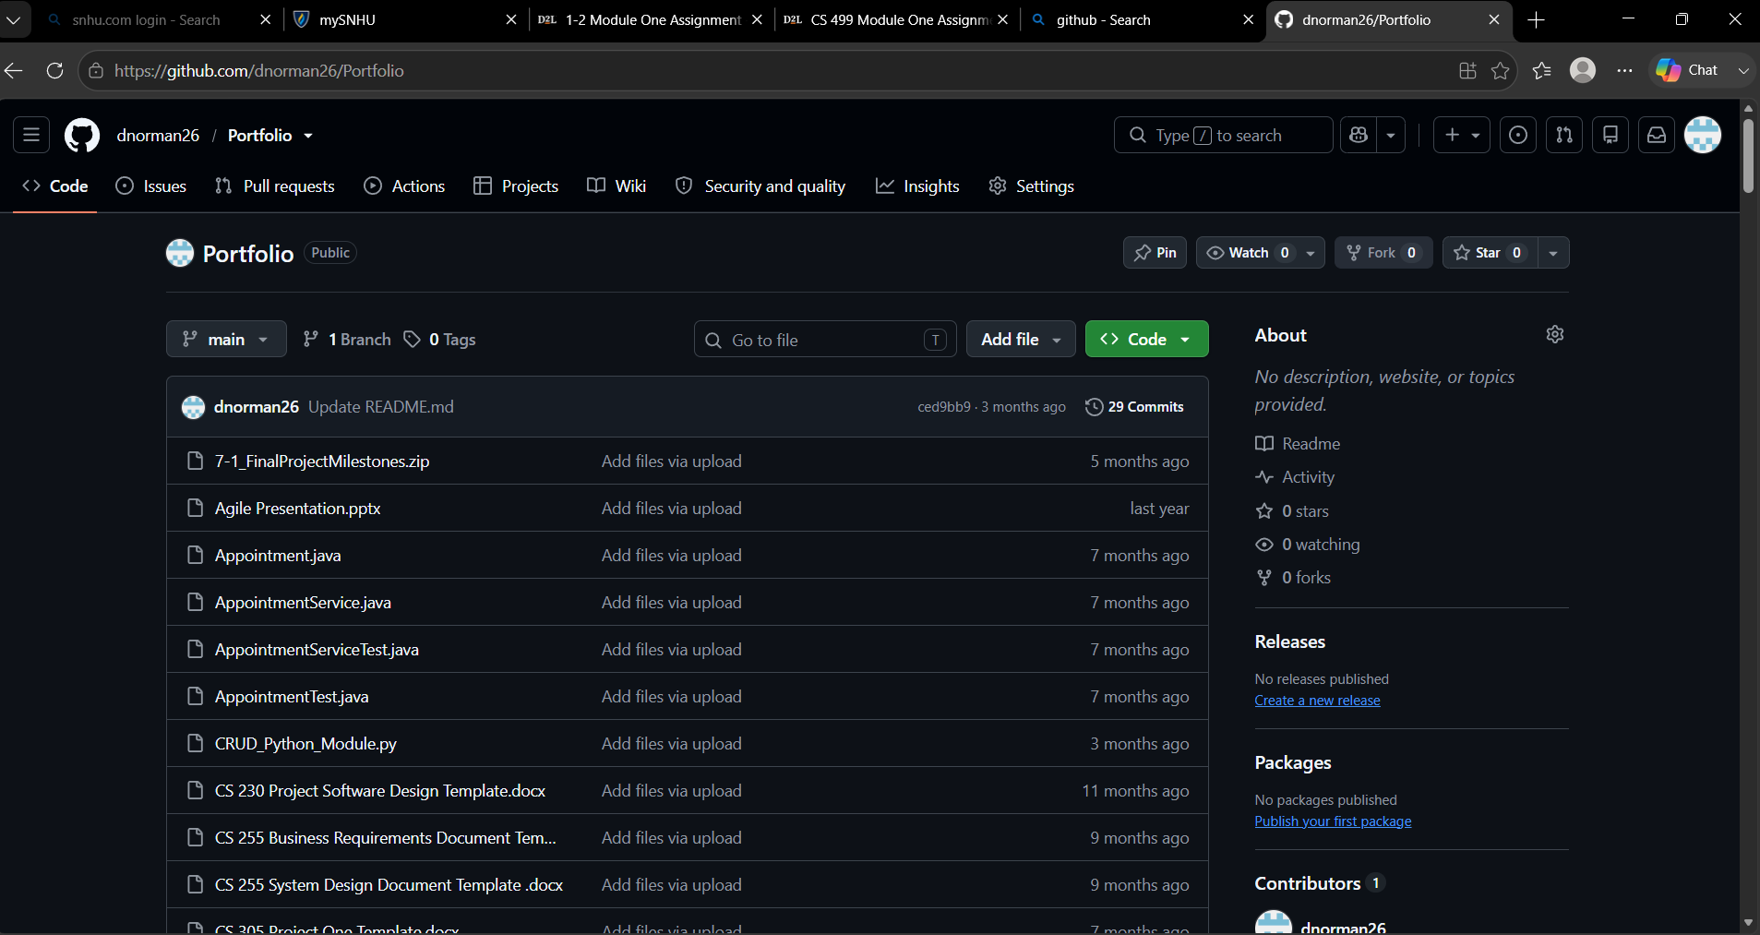
- Enhancement Plan:

  - Category One: Software Engineering and Design
    - Select an artifact that is aligned with the software engineering and design category and explain its origin. Submit a file containing the code for the artifact you choose with your enhancement plan.

I will be using my CS 360 Weight Tracker App. I built the app in the Mobile Architecture and Programming course. It has pages for login, entering weight, tracking goals, and notifications.

Note: Your artifact may be work from the following courses:

- IT 145: Foundation in Application Development
- CS 250: Software Development Lifecycle
- CS 260: Data Structures and Algorithms
- IT 315: Object Oriented Analysis and Design
- CS 320: Software Testing, Automation, and Quality Assurance
- CS 330: Computational Graphics and Visualization
- CS 340: Advanced Programming Concepts
- CS 350: Emerging Systems Architectures and Technologies
- CS 360: Mobile Architecture and Programming
- IT 365: Operating Environments
- IT 380: Cybersecurity and Information Assurance
- CS 405: Secure Coding
- CS 410: Reverse Software engineering
- IT 340: Network and Telecommunication Management
- IT 380: Cybersecurity and Information Assurance

    - Describe a practical, well-illustrated plan for enhancement in alignment with the category, including a pseudocode or flowchart that illustrates the planned enhancement.

The DashboardActivity does UI, logic, and database calls. I will split these into separate classes. Also, I will creating two features – edit weight feature and summary screen with a line graph.

Pseudocode for modular redesign

UI Module:
- Handles buttons, text fields, and screen updates
Logic Module:
- Validates weight input
- Calculates weekly progress
- Handles sorting and filtering
Database Module:
- Saves weight
- Updates weight
- Deletes weight
- Loads weight list

Pseudocode for edit weight feature

On Edit button click
Load weight ID
Show edit dialog with current weight and date
If user saves:
Validate new weight
Update database
Refresh list

Psudocode for weekly summary screen

Load all weights
Group weights by date
Calculate weekly average
Apply sorting/filtering options
Send data to graph
Draw line graph

For this category of enhancement, consider improving a piece of software, transferring a project into a different language, reverse engineering a piece of software for a different operating system, or expanding a project’s complexity. These are just recommendations. Consider being creative and proposing an alternative enhancement to your instructor.

Think about what additions to include to complete the enhancement criteria in this category. Since one example option is to port to a new language, that is the kind of scale that is expected. This does not mean you need to port to a new language but instead have an equivalent scale of enhancement. Underlying expectations of any enhancement include fixing errors, debugging, and cleaning up comments, but these are not enhancements themselves.

    - Explain how the planned enhancement will demonstrate specific skills and align with course outcomes.

      - Identify and describe the specific skills you will demonstrate that align with the course outcome.

For this category, I will be demonstrating that I can redesign my app to be more organized. Also, I will be showing that I can add new features.

      - Select one or more of the course outcomes below that your enhancement will align with.

Outcome 2, 3, 4, and 5

Course Outcomes:

- Employ strategies for building collaborative environments that enable diverse audiences to support organizational decision-making in the field of computer science.
- Design, develop, and deliver professional-quality oral, written, and visual communications that are coherent, technically sound, and appropriately adapted to specific audiences and contexts.
- Design and evaluate computing solutions that solve a given problem using algorithmic principles and computer science practices and standards appropriate to its solution while managing the trade-offs involved in design choices.
- Demonstrate an ability to use well-founded and innovative techniques, skills, and tools in computing practices for the purpose of implementing computer solutions that deliver value and accomplish industry-specific goals.
- Develop a security mindset that anticipates adversarial exploits in software architecture and designs to expose potential vulnerabilities, mitigate design flaws, and ensure privacy and enhanced security of data and resources.

  - Category Two: Algorithms and Data Structures

- Select an artifact that is aligned with the algorithms and data structures category and explain its origin. Submit a file containing the code for the artifact you choose with your enhancement plan. You may choose work from the courses listed under Category One.

Adding weekly progress calculations and sorting/filtering options will demonstrate I can design useful algorithms. Also, I will use this data to update the line graph which shows great logic and data handling skills.

- Describe a practical, well-illustrated plan for enhancement in alignment with the category, including a pseudocode or flowchart that illustrates the planned enhancement.
Adding calculated weekly averages or weekly gain/loss.
Adding sorting for weights and filter by date ranges.
Weekly summary graph

Pseudocode for weekly progress algorithm

Weights = load all weights
Group weights by week
For each week:
Average = sum(week weights) / number of entries
Add average to weekly list
Return weekly list

Pseudocode for sorting

If sort = highest:
Sort weekly list by average descending
If sort = lowest:
Sort weekly list by average ascending
If sort = recent:
Sort by date descending
If sort = oldest:
Sort by date ascending

Pseudocode for filtering

If filter = last 7 days:
Return weights where date >= today – 7
If filter = last 30 days:
Return weights where date >= today – 30
If filter = custom:
Return weights between startDate and endDate

For this category of enhancement, consider improving the efficiency of a project or expanding the complexity of the use of data structures and algorithms for your artifact. These are just recommendations. Consider being creative and proposing an alternative enhancement to your instructor. Note: You only need to choose one type of enhancement per category.

Think about what additions to include to complete the enhancement criteria in this category. Since one example option is to port to a new language, that is the kind of scale that is expected. Perhaps you might increase the efficiency and time complexity of an algorithm in an application and detail the logic of the increased time complexity. Remember, you do not need to port to a new language but instead have an equivalent scale of enhancement. Underlying expectations of any enhancement include fixing errors, debugging, and cleaning up comments, but these are not enhancements themselves.

- Explain how the planned enhancement will demonstrate specific skills and align with course outcomes.

  - Identify and describe the specific skills you will demonstrate to align with the course outcome.

Adding weekly progress calculations and sorting/filtering options will demonstrate I can design useful algorithms. Also, I will use this data to update the line graph which shows great logic and data handling skills.

  - Select one or more of the course outcomes listed under Category One that your enhancement will align with.

Outcome 3 and 4

  - Category Three: Databases

    - Select an artifact that is aligned with the databases category and explain its origin. Submit a file containing the code for the artifact you choose with your enhancement plan. You may choose work from the courses listed under Category One.

I am using the DBHelper class from the app. This class handles creating tables, inserting weight data, deleting entries, and loading data.

    - Describe a practical, well-illustrated plan for enhancement in alignment with the category, including a pseudocode or flowchart that illustrates the planned enhancement.

Adding a CHECK constraint to make sure weight is valid
Add INDEX on date
Add INDEX on weight

Pseudocode for database enhancement

CREATE TABLE weights (
Id INTEGER PRIMARY KEY AUTOINCREMENT,
Weight REAL CHECK(weight > 0 AND weight < 1000),
Date TEXT,
INDEX(weight),
INDEX(date),
);

INSERT INTO weights (weight, date)
VALUES (?,?);

For this category of enhancement, consider adding more advanced concepts of MySQL, incorporating data mining, creating a MongoDB interface with HTML/JavaScript, or building a full stack with a different programming language for your artifact. These are just recommendations; consider being creative and proposing an alternative enhancement to your instructor. Note: You only need to choose one type of enhancement per category.

Think about what additions to include to complete the enhancement criteria in this category. Since one example option is to port to a new language, that is the kind of scale that is expected. Perhaps you might increase the efficiency and time complexity of an algorithm in an application and detail the logic of the increased time complexity. Remember, you do not need to port to a new language but instead have an equivalent scale of enhancement. Underlying expectations of any enhancement include fixing errors, debugging, and cleaning up comments, but these are not enhancements themselves.
    - Explain how the planned enhancement will demonstrate specific skills and align with course outcomes.

      - Identify and describe the specific skills you will demonstrate that align with the course outcome.

I will show that I can improve a database by adding constraints, indexing, and secure queries.

      - Select one or more of the course outcomes listed under Category One that your enhancement will align with.

Outcome 4 and 5

- ePortfolio Overall Skill Set

  - Accurately describe the skill set to be illustrated by the ePortfolio overall.
    - Skills and outcomes planned to be illustrated in the code review

The code review will show that I can find problems in code and improve them. The outcomes illustrated are outcome 3 and 4 as I am evaluating solutions and using better techniques.

    - Skills and outcomes planned to be illustrated in the narratives

My enhancements will be clearly explained which connects to outcome 2.

    - Skills and outcomes planned to be illustrated in the professional self-assessment

The professional self-assessment I will show what I learned, my improvements, and how these skills help my career. I will illustrate outcome 4 as I am demonstrating growth in computing practices.

